**Software Requirements Specification**

**For project e-Furniture**

**Prepared by:**

**Trần Tấn Đạt**

**Lê Hữu Huy**

**Nguyễn Phương Tâm Tâm**

**Vũ Mạnh Khải**

**Lê Đức Nam**

**Trương Minh Hoàng**

**November 11, 2024**

**Table of contents**

1. **Introduction** 1.1 Background 1.2 Business opportunity 1.3 Business Objectives 1.4 Vision Statement
2. **Overall Description** 2.1. Product Perspective 2.2. User Classes and Characteristics 2.3. Operating Environment 2.4. Design and Implementation Constraints 2.5. Assumptions and Dependencies
3. **System Feature** 3.1 Use case 3.2 Use Case Specification
4. **Data Requirements** 4.1 Logical Data Model 4.2 Data dictionary
5. **External Interface Requirements** 5.1 User interfaces 5.2 Software interface
6. **Quality Attributes** 6.1 Usability Requirements 6.2 Performance Requirements 6.3 Security Requirements 6.4 Availability Requirements 6.5 Robustness Requirements 6.6 Wireframe 6.8 Prototype
7. **Swimlane**
8. **State machine**
9. **Sequence diagram**
10. **Class diagram**

**1. Introduction**

**1.1 Background**

In today's fast-paced world, the demand for cross-cultural communication skills among students has skyrocketed. These skills are not only crucial for seamlessly blending into global environments for learning and employment but also have a profound impact on expanding career opportunities and personal growth . Unfortunately, many individuals fail to recognize the significance of these skills, and educational programs often neglect to prioritize their integration

**1.2 Business opportunity**

LearnHub not only serves as a catalyst for individual learning journeys but also offers substantial benefits for businesses. By prioritizing the development of Global Citizenship skills, LearnHub contributes to building a workforce that excels in cross-cultural competence, a crucial asset for companies operating in a globalized world. This proficiency enhances communication, collaboration, and adaptability within diverse teams.

Furthermore, businesses can leverage LearnHub to customize training programs for employees, ensuring that their workforce is equipped with the necessary skills to navigate international markets effectively. The platform's integrated assessment process provides valuable data for businesses to assess and address skill gaps, enabling strategic talent development initiatives. This data-driven approach supports informed decision-making in workforce planning and training investments.

In essence, LearnHub becomes a strategic partner for businesses, fostering a globally aware and skilled workforce, ultimately contributing to enhanced competitiveness, corporate social responsibility, and sustainable growth in an interconnected global landscape.

**1.3  Business Objectives**

BO-1: More and more Students join web app by 40% within 6 months following initial release.

Scale: More and more students join the web app will improve quality

BO-2: Enhance User Engagement and Retention

Objective: Increase user engagement and retention within the web app.

Scale: Monitor and analyze user activity, feedback, and interactions to ensure that as more students join the platform, they find value, remain active, and continue using the application.

BO-3: Optimize Course Recommendations and Selection

Objective: Improve the efficiency and effectiveness of course recommendations for students.

Scale: As more students join the web app, refine the recommendation algorithms based on user preferences, feedback, and historical data. Aim to increase the accuracy of course suggestions, leading to higher satisfaction and better utilization of the platform.

**1.4 Vision Statement**

For aspiring learners seeking a transformative educational experience:

LearnHub addresses the need for personalized and effective learning,

The Learning Catalyst, is an innovative online learning platform,

that leverages advanced algorithms, adaptive assessments, and progress tracking to tailor educational journeys for individual growth. Unlike traditional alternatives and conventional learning methods. Our product stands out through its dynamic adaptability, fostering a vibrant community where students connect, collaborate, and inspire one another. LearnHub encourages not just knowledge acquisition, but also the development of essential soft skills, placing learners at the center of their educational experience. We are committed to empowering lifelong knowledge seekers and driving positive societal impact through cutting-edge and learner-centric approaches.

**2. Overall Description**

**2.1. Product Perspective**

Our online learning platform represents an innovative solution designed to address the limitations of existing online learning systems in Vietnam. With a focus on providing high-quality educational resources and clear learning pathways, our platform offers a comprehensive and user-friendly interface for learners of all ages. Key components include intuitive main and search pages for seamless course discovery, a dedicated Course Manager Dashboard for efficient course creation and management, an Admin Dashboard for centralized platform administration, and integrated payment processing interfaces for secure transactions. Our platform empowers users to tailor their learning journeys according to their preferences and pace, fostering personalized and effective learning outcomes. With multi-device accessibility, our platform ensures convenience and accessibility for users across different devices and operating systems. Overall, our platform serves as a comprehensive solution for individuals seeking quality online education in Vietnam.

**2.2. User Classes and Characteristics**

**For Students:**

* LearnHub offers a diverse range of online courses tailored to individual interests and learning goals.
* Students can easily browse, enroll in, and participate in courses through an intuitive platform.
* Feedback mechanisms allow students to provide input on courses and instructors, ensuring a high-quality learning experience.

**For Course Managers:**

* Course managers have the tools to create, manage, and monitor courses effectively.
* They can upload course content, schedule sessions, and track student progress to ensure an engaging learning environment.
* Interaction with students allows course managers to provide support and guidance throughout the learning journey.

**For Admins:**

* Admins play a crucial role in maintaining the integrity and functionality of the LearnHub platform.
* They oversee user accounts, manage payment activities, and ensure compliance with platform guidelines.
* Strategic decision-making helps shape the direction and growth of LearnHub, ensuring its continued success in delivering quality online education.

**2.3. Operating Environment**

* Our system will be a web application developed with Angular, using Visual Studio Code. The back-end will be written in Java, utilizing the Spring Boot framework in IntelliJ, and connect together via API.
* The database will be built on a standard SQL platform, utilizing SQL Server.
* Users, including students and instructors, can access the platform on the internet using browsers such as Google Chrome (version 100 to 118) and Microsoft Edge (version 100 to 188).

**2.4. Design and Implementation Constraints**

CO-1: The system’s design, code, and maintenance documentation shall conform to the *Process Impact Intranet Development Standard, Version 1.3* [2].

CO-2: The system shall use the current corporate standard Oracle database engine.

CO-3: All HTML code shall conform to the HTML 5.0 standard

**2.5. Assumptions and Dependencies**

or our system, the following design and implementation constraints apply:

* **Data Storage:** We utilize Microsoft SQL Server for data storage to ensure quality, durability, and reliability.
* **Website Functionalities:** All website functionalities are implemented using a RESTful API architecture with Spring Boot for the backend and Angular for the frontend. This choice ensures flexibility, scalability, and ease of maintenance.
* **Query-Data Retrieval (QDR) Performance:** Our system must efficiently process all user-generated data updates within a reasonable timeframe to maintain responsiveness and user satisfaction.
* **Setup and Maintenance:** The setup and maintenance of our system involve tasks such as installation, hosting, host-security configuration, and ongoing administration to ensure smooth operation and security.

**3. System Feature**

**3.1 Use case**

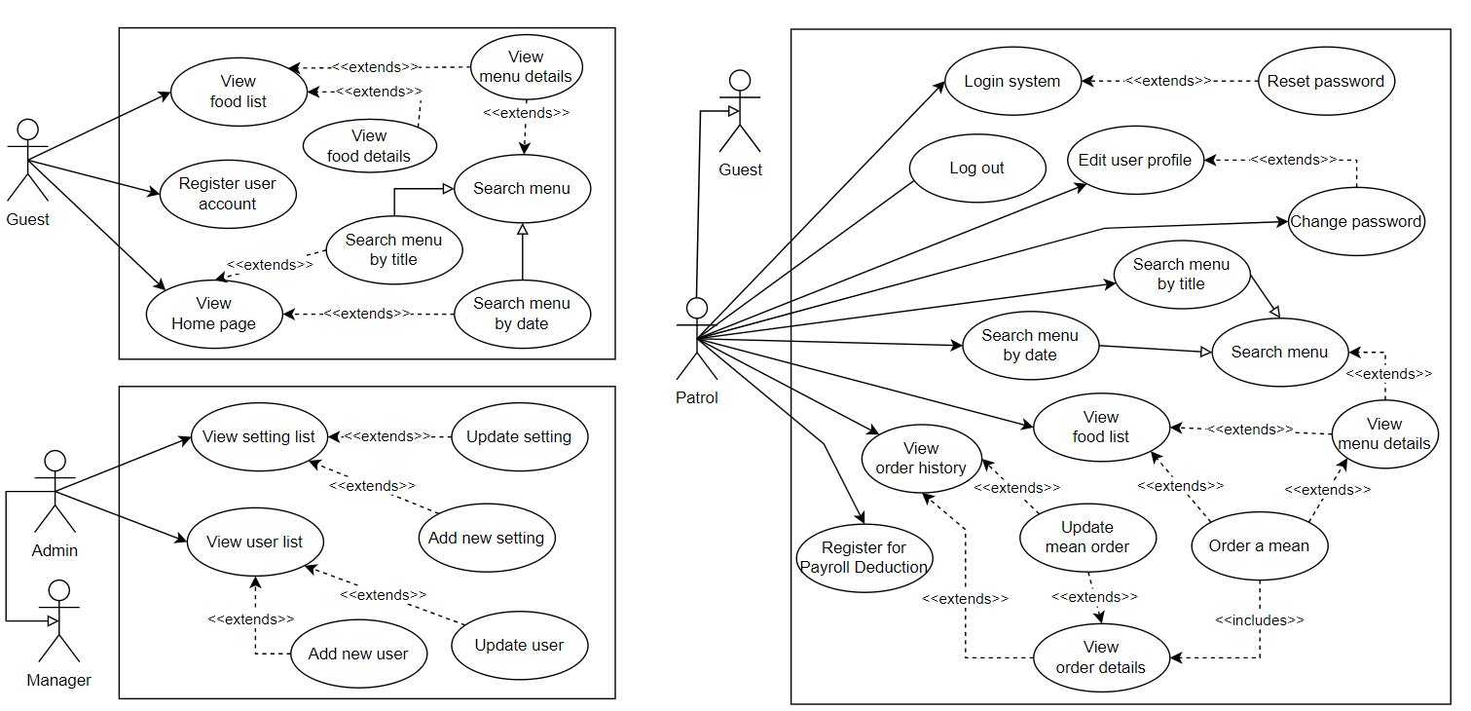

**3.2 Use Case Specification**

### 

## 

| ID and Name: | **Comment/Rating** | | |
| --- | --- | --- | --- |
| Created By: | Trần Tấn Đạt | Date Created: | 20/1/23 |
| Primary Actor: | Student | Secondary Actors: | Course Manager |
| Description: | A student accesses the LearnHub from any device with an internet connection, browses through available courses, selects a course of interest, and gains ability to comment and rating the course | | |
| Trigger: | The student logs into the LearnHub | | |
| Preconditions: | **PRE-1:** The student is registered for the course.  **PRE-2:** The student has a valid login to the LearnHub | | |
| Postconditions: | **POST-1:** Student successfully submits comments and a rating for the selected course.  **POST-2:** The LearnHub system captures and stores the student's comments and rating, updating the course's overall feedback metrics in real-time within the learning analytics system. | | |
| Normal Flow: | 1. The student initiates a session by logging into LearnHub. 2. LearnHub's interface displays a comprehensive list of available courses. 3. Upon selecting a specific course, LearnHub dynamically generates and presents the course homepage, which includes modules, lecture videos, reading materials, quizzes, and assignments. 4. As the student navigates through the course materials, LearnHub enables a feature for submitting comments and a rating. 5. The student takes advantage of this feature, providing insightful comments and assigning a rating to the course. 6. LearnHub seamlessly processes and records the submitted comments and rating, updating the course's overall feedback metrics. 7. The learning analytics system, integrated with LearnHub, captures and stores the student's engagement data, including the newly provided comments and rating. | | |
| Alternative Flows: | **Comment/Rating for Multiple Courses**  **Student Expresses Interest in Rating More Courses:**   1. After completing comments and a rating for one course, the student expresses interest in reviewing and rating additional courses. 2. LearnHub facilitates the seamless return to the course list or homepage. 3. The student selects another course and proceeds to provide comments and a rating. 4. This process repeats until the student has reviewed all desired courses. 5. The student can then log out or explore other LearnHub features. | | |
| Exceptions: | **Temporary Unavailability of Comment/Rating Feature for Additional Courses:**   1. If the comment/rating feature for additional courses is temporarily unavailable, LearnHub notifies the student and provides an estimated resolution time. 2. During this period, students can still access other course materials. 3. Upon resolution, the student can resume providing comments and ratings for additional courses. | | |
| Priority: | High | | |
| Frequency of Use: | Approximately 500 users, with varying usage patterns throughout the day. Peak usage is expected during evenings and weekends. | | |
| Business Rules: | Comment have maximum words is 3000 The rating scale is limited to a predefined range (1 to 5 stars). | | |
| Other Information: | 1. Comments and ratings submitted by students are visible to other enrolled students for the same course 2. Students receive notifications within LearnHub when there are responses to their submitted comments or ratings. 3. LearnHub employs a moderation system to identify and address inappropriate or offensive comments. | | |
| Assumptions: |  | | |

| Created By: | Vũ Mạnh Khải | Date Created: | 20/1/23 |
| --- | --- | --- | --- |
| Primary Actor: | Course Manager | Secondary Actors: | None |
| Description: | This includes adding new courses, updating existing ones, and ensuring the availability of course materials. The administrator also oversees user access and resolves any technical issues related to course content. | | |
| Trigger: | The Course Manager logs into the E-Learning System. | | |
| Preconditions: | PRE-1: The Course Manager has a valid login to the E-Learning System.  PRE-2: The Course Manager has the necessary permissions for course management. | | |
| Postconditions: | POST-1: Course information and materials are updated as per the administrator's actions.  POST-2: Any technical issues related to course content are addressed promptly. | | |
| Normal Flow: | 1. The Course Manager logs into the E-Learning System using their valid credentials. 2. The E-Learning System authenticates the Course Manager and presents the admin dashboard. 3. In the admin dashboard, the Course Manager navigates to the course management section: 4. 3.1 Selects "Add New Course" to create a new course, providing details such as course name, modules, lecture videos, reading materials, quizzes, and assignments. 5. 3.2 Chooses "Edit Course" to modify existing course details, including content and availability. 6. 3.3 Accesses the "Ensure Availability" option to verify the availability of course materials and troubleshoots any technical issues, if identified. 7. After making changes, the Course Manager saves the modifications. 8. The E-Learning System confirms the successful update, and the administrator logs out or proceeds to other admin functionalities. | | |
| Alternative Flows: | Course Manager Searches for a Specific Course: If the administrator needs to find a particular course, they can use the search functionality. | | |
| Exceptions: | 1. *E1 Unavailability of* Course Manager *Functionality:*   *If the* Course Manager *features are not available due to maintenance or technical issues, the system informs the* Course Manager *and provides an estimated resolution time.* | | |
| Priority: | High | | |
| Frequency of Use: | Course Manager activities may vary, with peak usage during course creation and maintenance periods. | | |
| Business Rules: | Ensure the security and integrity of user data and learning materials. | | |
| Other Information: | 1. User Feedback Integration:  The E-Learning System actively gathers and integrates user feedback to enhance the overall user experience and address specific user needs.  2.Collaborative Content Management:  The system supports collaborative content creation and management, enabling multiple Course Manager to work on course materials simultaneously.  3. User Support System:  A comprehensive user support system is in place to assist both administrators and students with any inquiries, technical issues, or usage-related questions. | | |
| Assumptions: |  | | |

**5. External Interface Requirements**

**5.1**   **User Interfaces**

UI-1: The CMS user interface shall adhere to the organization's Web Application User Interface Standard, including design principles, layout, and accessibility.

UI-2: The system shall provide readily accessible help functionality from each displayed page to explain how to use that page.

UI-3: The user interface shall allow complete navigation and course selection using the keyboard alone, in addition to using mouse and keyboard combinations.

**5.2** **Software Interfaces**

SI-1: Identity Management System (IMS):

Function: Authenticates users and authorizes access based on assigned roles (course manager, student, staff manager, admin).

Data Exchange:

From CMS to IMS: Sends user credentials for authentication.

From IMS to CMS: Receives user information (name, email, role) and authorization status.

SI-2: Payment System:

Function: Processes online payments for courses and manages financial transactions.

Data Exchange:

From CMS to Payment System: Sends course enrollment details, payment amount, and user information for payment processing.

From Payment System to CMS: Receives payment confirmation or rejection status and updates course enrollment records accordingly.

**5.3** **Hardware Interfaces**

HI-1: The CMS shall operate on popular web browsers (Chrome, Firefox, Safari, Edge) with the latest version.

HI-2: The system shall support access from various devices (desktop, laptop, tablet, smartphone).

**5.4** **Communications Interfaces**

CI-1: The system shall use the HTTPS protocol to secure data transmission between users and the system.

CI-2: The system shall provide notification methods for users, including:

Email: notifications about course registration, course updates, payments, etc.

Internal messaging: notifications about system activities, messages from instructors or administrators.

CI-3: The system may integrate with external communication tools (like Slack, Microsoft Teams) to enhance collaboration and interaction among users.

**6. Quality Attributes**

## **6.1. Usability Requirements**

USE-1: Navigation Simplicity: Users should be able to easily navigate through the platform, with clear menus and intuitive page layouts.

USE-2: Accessibility: The platform must adhere to accessibility standards to accommodate users with disabilities, ensuring equal access to educational resources.

USE-3: Responsive Design: The user interface should adapt to various screen sizes and devices to provide consistent usability across different platforms.

USE-4: Help Functionality: Comprehensive help functionality should be readily accessible from each page to assist users in understanding platform features and navigation.

## **6.2 Performance Requirements**

PER-1: Response Time: The system should respond promptly to user interactions, with minimal delay in loading pages and processing requests.

PER-2: Scalability: The platform should be scalable to accommodate increasing numbers of users and course offerings without compromising performance.

PER-3: Concurrent Users: The system should support a large number of concurrent users accessing courses and interacting with the platform simultaneously.

PER-4:Data Retrieval Speed: Queries for retrieving course information, user data, and other system resources should be executed efficiently to minimize loading times.

## **6.3 Security Requirements**

SEC-1: Data Encryption: All sensitive user data, including personal information and payment details, should be encrypted during transmission and storage to prevent unauthorized access.

SEC-2: Authentication and Authorization: User authentication should be implemented securely, with multi-factor authentication options available for added security. Access to system resources should be controlled based on assigned roles and permissions.

SEC-3: Secure Payment Processing: Payment transactions should be processed securely using encryption protocols and compliance with PCI-DSS standards to protect users' financial information.

SEC-4: Regular Security Audits: The platform should undergo regular security audits and vulnerability assessments to identify and address potential security threats proactively.

## **6.4 Safety Requirements**

SAF-1: Content Moderation: User-generated content, including course materials and interactions, should be moderated to prevent the dissemination of inappropriate or harmful content.

SAF-2: User Reporting Mechanism: Users should have the ability to report any abusive or inappropriate behavior, ensuring prompt intervention and resolution by platform administrators.

SAF-3: Compliance with Legal Regulations: The platform should comply with relevant data protection laws and regulations to safeguard user privacy and rights.

SAF-4: Emergency Response Protocol: The platform should have an emergency response protocol in place to address critical incidents or emergencies affecting user safety and well-being.

## **6.5 Availability Requirements**

AVL-1: Uptime Guarantee: The platform should strive for high uptime, with minimal scheduled maintenance windows and proactive monitoring to detect and address system failures promptly.

AVL-2: Redundancy and Failover: Critical system components should be redundant, with failover mechanisms in place to ensure continuous operation in the event of hardware or software failures.

AVL-3: Disaster Recovery Plan: The platform should have a comprehensive disaster recovery plan to restore operations swiftly in the event of catastrophic events or data loss incidents.

**6.6 Wireframe**

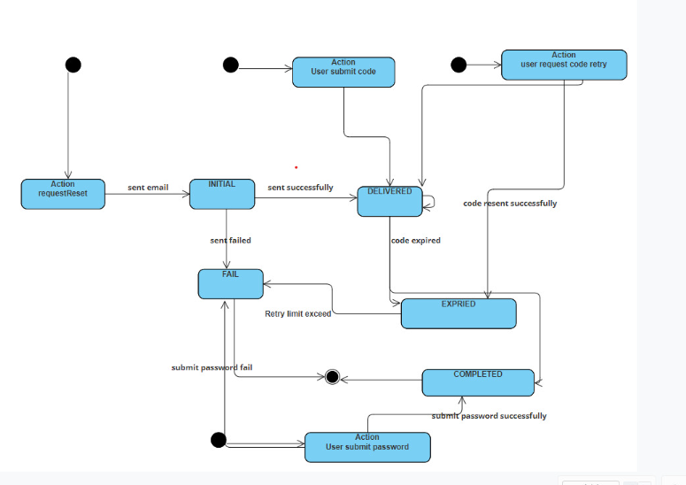





**6.8 Prototype**

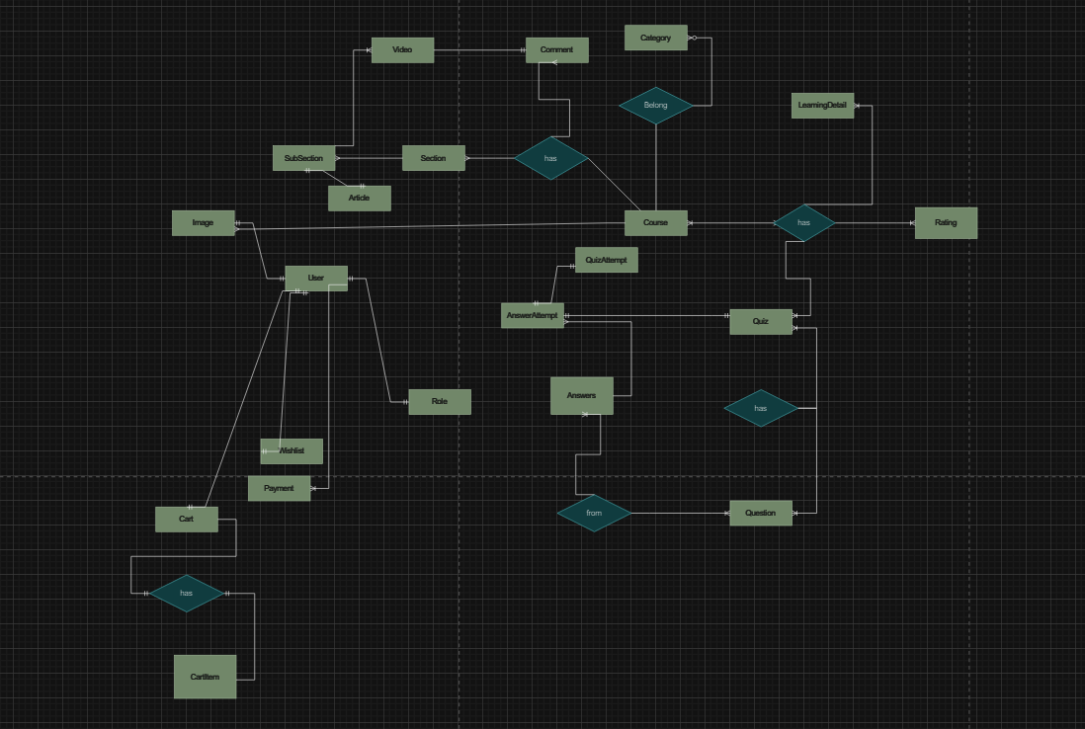

**7. Swimlane**

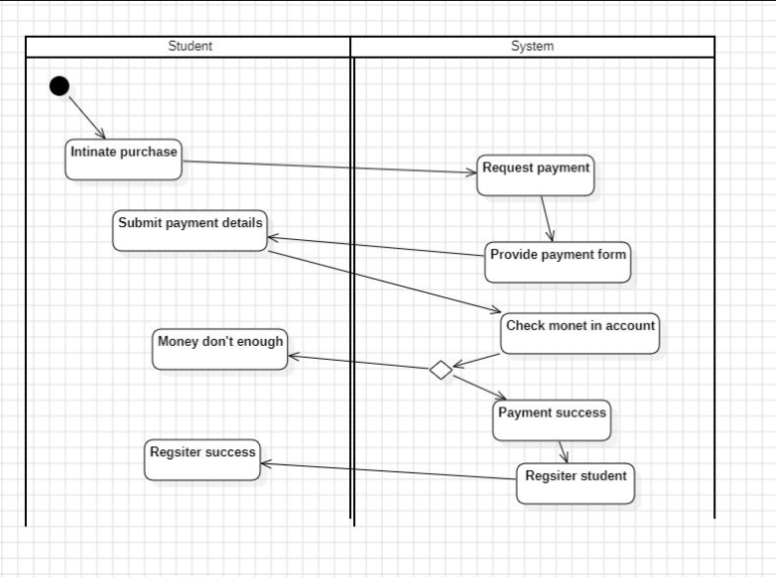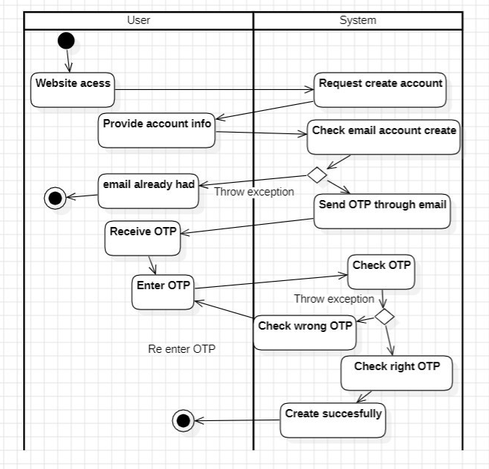

**8. State machine**

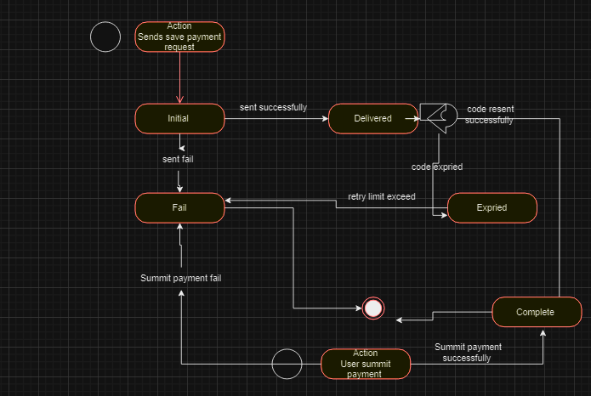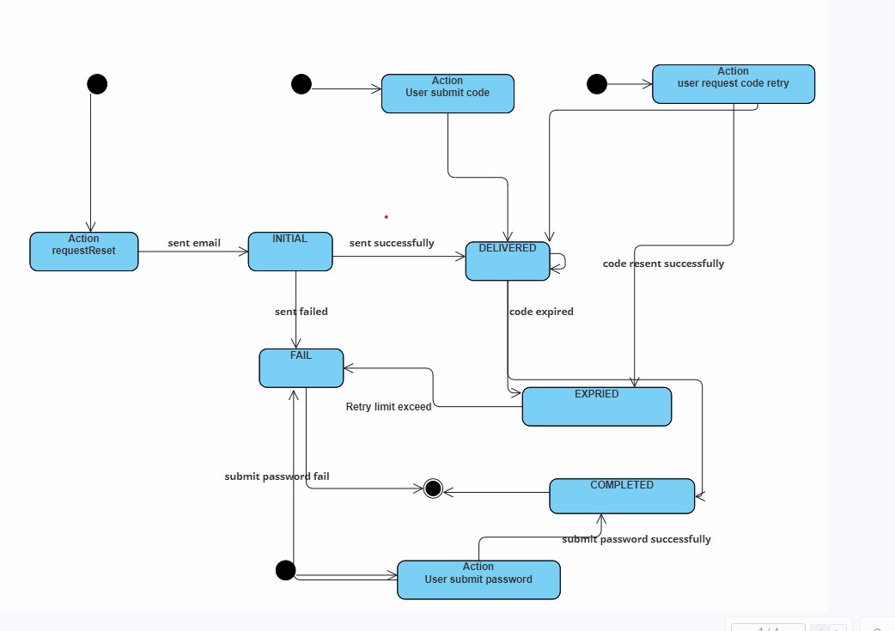

**9. Sequence diagram**

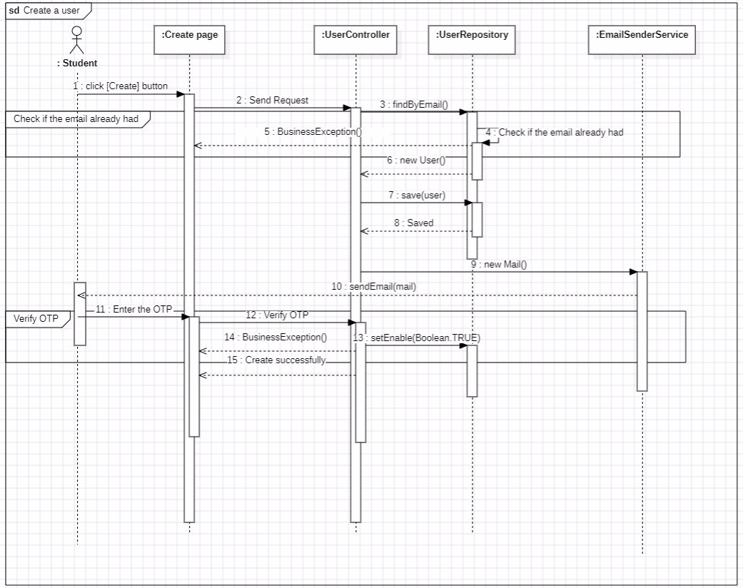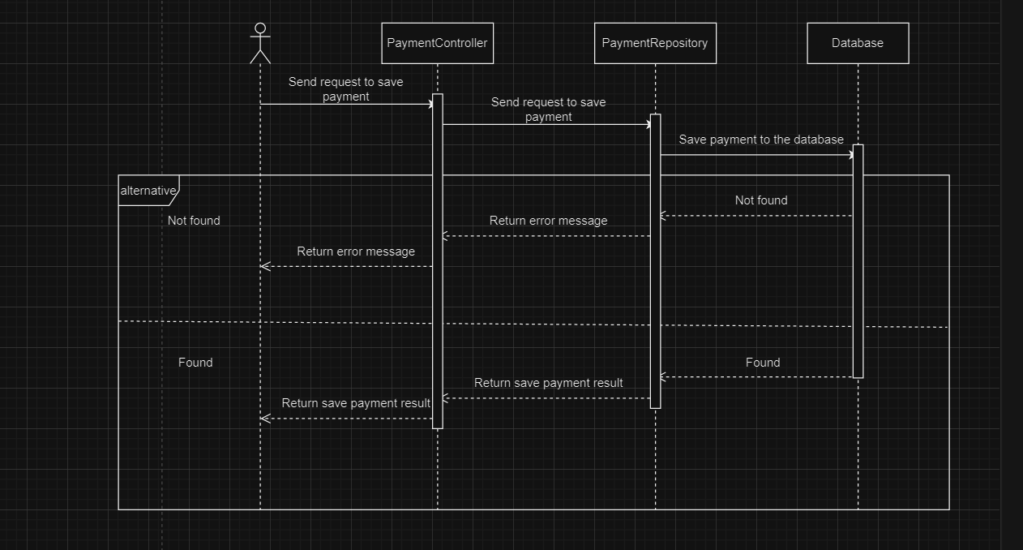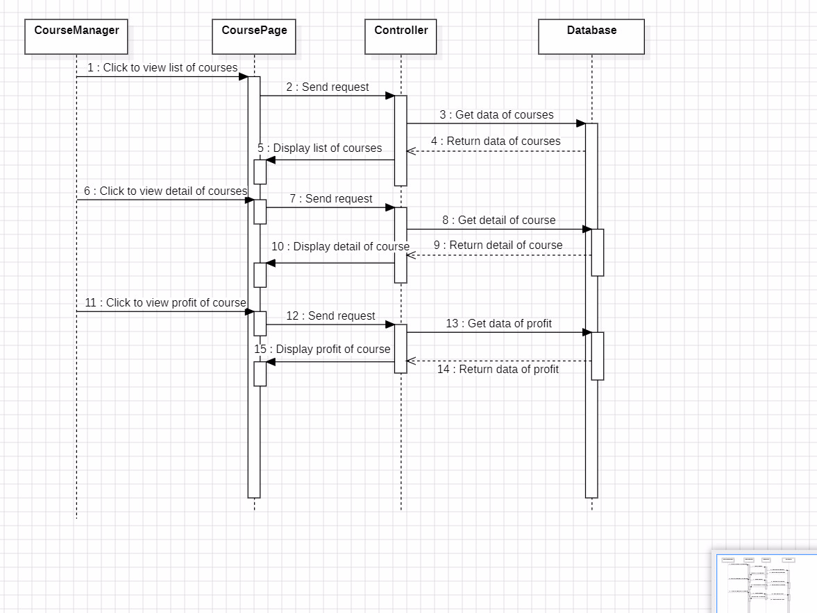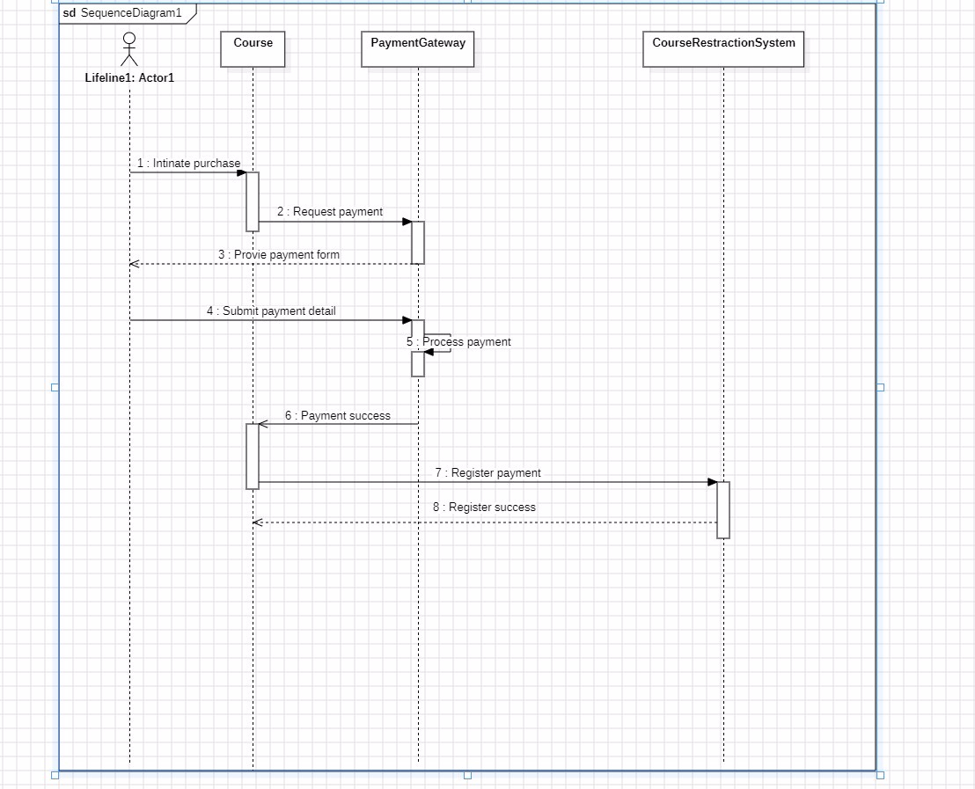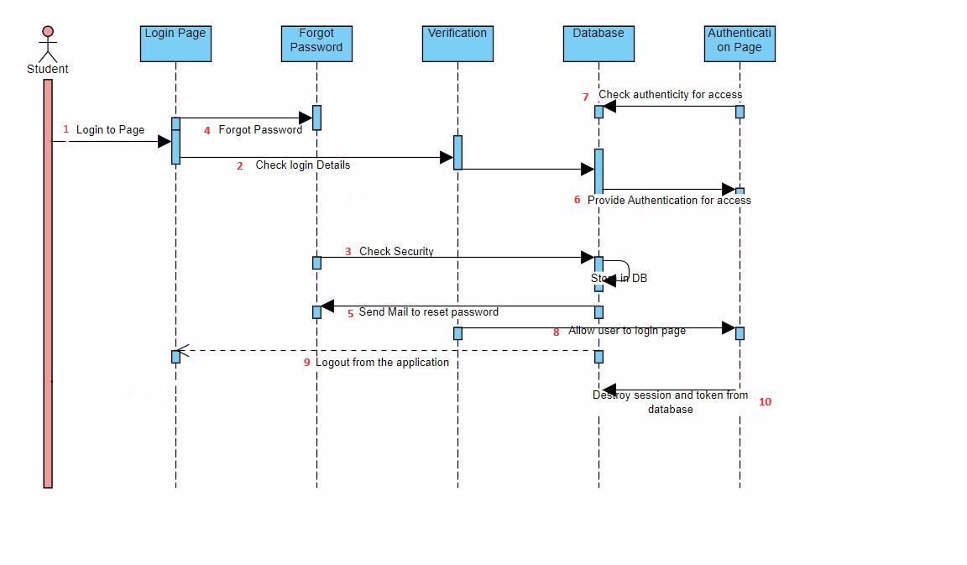

**10. Class diagram**

